Raw ideas:

**Thesis Statement:**  
The integration of multimodal data—such as MRI, CT, PET scans, and clinical metadata—significantly enhances the performance of machine learning models in medical imaging by providing complementary information, improving diagnostic accuracy, enabling robust disease classification, and supporting personalized treatment planning.

**Abstract (Mini Format):**  
The limitations of single-modality medical imaging often result in incomplete representations of complex pathologies. This mini thesis proposes that the fusion of multiple data modalities, including anatomical, functional, and textual clinical data, offers a more holistic view of patient health. By leveraging advanced machine learning techniques—particularly deep learning architectures—multimodal approaches can learn richer feature representations, leading to improved sensitivity and specificity in disease detection. This research emphasizes the value of cross-modal attention mechanisms, data alignment strategies, and the need for standardized multimodal datasets to realize the full potential of AI-driven healthcare solutions.

**1. Introduction**

Medical imaging plays a central role in disease diagnosis, monitoring, and treatment planning. Traditionally, diagnostic systems rely on single-modality data such as CT or MRI scans. However, these modalities often provide only partial insights—for instance, CT offers excellent bone detail, while MRI is superior for soft tissue contrast. In clinical practice, physicians often rely on multiple data sources—including lab results, radiological reports, and patient history—to form a comprehensive diagnosis. Machine learning (ML), especially deep learning, has shown immense potential in automating image analysis. By integrating multimodal data, ML models can learn synergistic representations that capture both anatomical and physiological aspects of disease, leading to improved performance and clinical applicability.

**2. Related Work**

Prior work has shown that deep learning models can outperform traditional methods in various imaging tasks like tumor detection, segmentation, and classification. Recent studies have explored multimodal learning frameworks that combine image data with other sources such as electronic health records (EHR), genomic data, and natural language from clinical notes. Techniques such as attention mechanisms, late fusion, and encoder-decoder architectures have emerged as effective tools for handling heterogeneous data.

**Literature review:**

• **"Review of multimodal machine learning approaches in healthcare"**  
This paper provides an overview of key data modalities commonly used in clinical practice and describes different fusion approaches at both modality- and feature-level.

• **"A review of deep learning-based information fusion techniques for multimodal medical image classification"**  
This review discusses deep learning-based information fusion techniques for multimodal medical image classification.

• **"Multimodal artificial intelligence models for radiology"**  
This article reviews various computational approaches that can be applied to multimodal datasets in radiology and discusses them from technical and application perspectives.

• **"Multimodal Machine Learning in Image-Based and Clinical Data"**  
This survey navigates the current landscape of multimodal machine learning, focusing on its profound impact on medical image analysis and clinical decision support systems.

• **"Beyond Medical Imaging: A Review of Multimodal Deep Learning in Radiology"**  
This review explores multimodal deep learning in radiology, examining both imaging and clinical variables.

**3. Methodology**

**3.1 Data Collection and Preprocessing**

Data sources may include:

* **Imaging modalities**: MRI, CT, PET, ultrasound
* **Non-imaging data**: Demographics, lab results, genomics, textual reports

Data alignment and preprocessing involve image normalization, spatial co-registration, feature extraction from text (e.g., using NLP), and handling missing data across modalities.

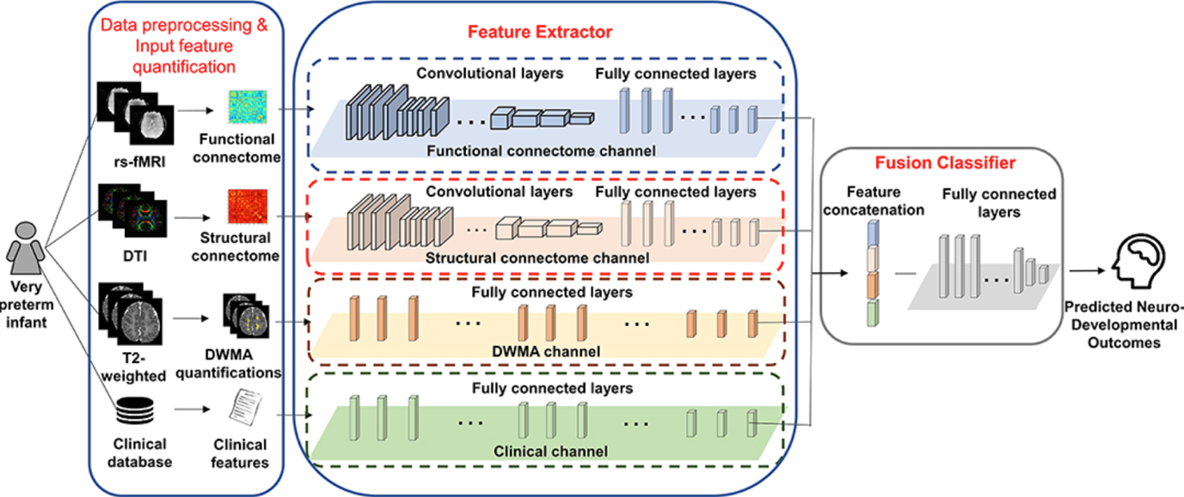

**3.2 Model Architecture**

* **Modality-specific encoders**: Separate neural networks are used to extract features from each modality.
* **Fusion techniques**:
  + *Early fusion* merges data at the input level.
  + *Intermediate fusion* combines features from separate branches in the network.
  + *Late fusion* aggregates predictions from each modality.
  + *Attention mechanisms* selectively focus on informative features across modalities.

**3.3 Training and Evaluation**

* Supervised learning using labeled data (e.g., tumor present/absent)
* Evaluation metrics: Accuracy, sensitivity, specificity, AUC-ROC
* Validation strategies: Cross-validation, external dataset testing, ablation studies to compare unimodal vs. multimodal performance

**4. Results and Discussion**

Multimodal models consistently outperform unimodal baselines in classification and segmentation tasks across several benchmarks. For example, combining MRI with patient metadata can improve tumor grading accuracy. However, challenges remain, such as data heterogeneity, limited multimodal datasets, and interpretability of complex models. The discussion highlights trade-offs in model complexity, computation, and clinical interpretability.

**5. Conclusion**

Integrating multimodal data in machine learning pipelines significantly enhances the diagnostic power of medical imaging systems. It allows for a more holistic view of patient health, reflecting real-world clinical decision-making. Future work should focus on improving data harmonization, interpretability of multimodal models, and building large-scale, standardized datasets. Ultimately, multimodal machine learning holds the promise of advancing precision medicine and improving patient outcomes.